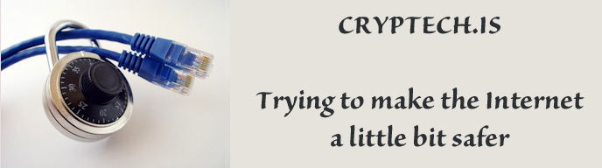
Recent revelations have called into question the integrity of some of the implementations of basic cryptographic functions and devices used to secure communications on the Internet. Serious questions have been raised about implementations of cryptographic algorithms in software and particularly hardware. And those questions are such that only an open-source approach can possibly provide good answers. We are therefore embarking on development of an open-source hardware cryptographic engine that meets the needs of high assurance Internet infrastructure systems that use cryptography. The open-source hardware cryptographic engine will be of general use to the broad Internet community, covering needs such as secure email, web, DNS, PKIs, etc. The intent is that the resulting open-source hardware cryptographic engine can be built by anyone from public hardware specifications and open-source firmware. Anyone can then operate it without fees of any kind. The project to build this open-source hardware however needs to be properly funded so that a professional product results that can meet the requirements of real Internet applications.
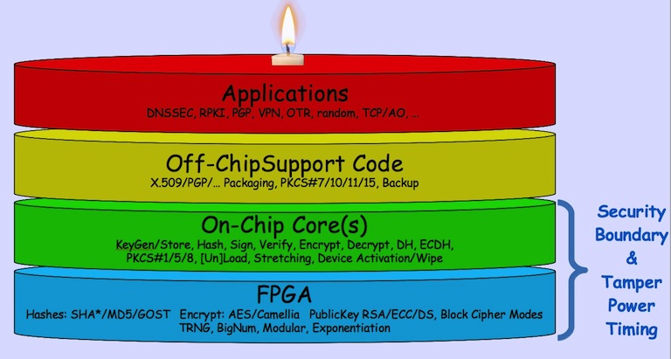
Core Team
Fredrik Thulin
Jacob Appelbaum
Jakob Schlyter
Joachim Strömbergson
Leif Johansson
Linus Nordberg
Lucy Lynch
Patrik Wallström
Peter Stuge
​Randy Bush
​Rob Austein
Steven Bellovin
Basil Dolmatov
What do we need? At this point we have an experienced core-team and our need now is for funding to allow us to turn our project plans into reality, so we're looking for significant commitments to help build the above.

The project funding will be managed by TBDFoundation which is a Swedish Thingy with more details here.

http://cryptech.is/
tech@cryptech.is (general)
org@cryptec.is (funding)

